Introduction to IP AddressingTheory
IP Addressing and Subnetting Assignment — Detailed Answers
1. Key differences between IPv4 and IPv6
IPv4 and IPv6 are two versions of the Internet Protocol (IP) used to identify devices and route data across networks. IPv6 was developed to address the limited address space of IPv4 and provide improvements for modern networking.
IPv4 | IPv6
Uses 32-bit addresses. | Uses 128-bit addresses.
Supports about 4.3 billion ( \(2^{32}\) ) addresses. | Supports about \(3.4 \times 10^{38}\) ( \(2^{128}\) ) addresses.
Written in dotted-decimal format, e.g. 192.168.1.10. | Written in hexadecimal, separated by colons, e.g. 2001:db8::10.
Has four octets separated by dots. | Has eight groups of hexadecimal digits, separated by colons (with shortening rules).
Common subnet mask: 255.255.255.0 or /24. | Uses prefix notation, e.g. /64; no dotted-decimal subnet mask.
Broadcast addresses are supported. | Does not use broadcast; uses multicast and anycast instead.
NAT is commonly used to conserve public IPv4 addresses. | Provides a much larger address space, reducing the need for address-conservation NAT.
ARP is used to resolve IPv4 addresses to MAC addresses on local networks. | Neighbor Discovery Protocol (NDP) performs address-resolution functions using ICMPv6.
Can use manual configuration or DHCP. | Supports manual configuration, DHCPv6 and Stateless Address Autoconfiguration (SLAAC).
IPsec support is available but implementation and use vary. | Includes standardized support for IPsec, although it is not mandatory for every connection.
Conclusion: IPv4 uses 32-bit addresses, while IPv6 uses 128-bit addresses. IPv6 provides a significantly larger address space and uses different methods for local network discovery and configuration.
2. Assign static IPv4 addresses to four home Wi-Fi devices
Given network: 192.168.10.0/24
A /24 network uses the subnet mask 255.255.255.0. The network address is 192.168.10.0, and the broadcast address is 192.168.10.255. Therefore, the usable host range is 192.168.10.1 to 192.168.10.254.
Static IP allocation table
Device | IP address | Subnet mask | Default gateway
Laptop | 192.168.10.10 | 255.255.255.0 | 192.168.10.1
Phone | 192.168.10.11 | 255.255.255.0 | 192.168.10.1
Smart TV | 192.168.10.12 | 255.255.255.0 | 192.168.10.1
Printer | 192.168.10.13 | 255.255.255.0 | 192.168.10.1
These are example static assignments. They assume the home router's LAN address is 192.168.10.1 and that these addresses are available.
Explanation
- IP address: Uniquely identifies each device on the local network.
- Subnet mask: Defines which portion of the IP address represents the network. Here, /24 means the first 24 bits identify the network.
- Default gateway: The router address used to reach devices outside the local subnet.
- Static IP: An address configured manually rather than assigned dynamically by DHCP.
Important: Before setting static addresses, ensure they do not conflict with DHCP-assigned addresses or existing devices. You can reserve the addresses in the router's DHCP settings.
3. Calculate subnets and hosts using a /27 subnet mask
Given: 192.168.1.0 network, divided using a /27 CIDR prefix.
Step 1: Convert the CIDR prefix to a subnet mask
A /27 prefix means 27 bits are used for the network and 5 bits remain for hosts.
Subnet mask:
255.255.255.224
The last octet is 224, so the block size is:
\[ 256-224=32 \]
Therefore, subnet network addresses increase in increments of 32.
Step 2: Calculate the number of subnets and hosts
Assuming the original network is 192.168.1.0/24:
- Bits borrowed from the original /24: \(27-24=3\)
- Number of subnets: \(2^3=8\)
- Host bits remaining: \(32-27=5\)
- Addresses per subnet: \(2^5=32\)
- Usable hosts per subnet: \(32-2=30\)
Number of subnets
8
Usable hosts per subnet
30
Subnet mask
255.255.255.224
Step 3: List the first three subnet ranges
Subnet | Network address | First usable host | Last usable host | Broadcast address
1 | 192.168.1.0 | 192.168.1.1 | 192.168.1.30 | 192.168.1.31
2 | 192.168.1.32 | 192.168.1.33 | 192.168.1.62 | 192.168.1.63
3 | 192.168.1.64 | 192.168.1.65 | 192.168.1.94 | 192.168.1.95
Step 4: Understand the subnet ranges
Subnet 1
32 addresses
192.168.1.0 → 192.168.1.31
Network: .0 · Usable: .1–.30 · Broadcast: .31
Subnet 2
32 addresses
192.168.1.32 → 192.168.1.63
Network: .32 · Usable: .33–.62 · Broadcast: .63
Subnet 3
32 addresses
192.168.1.64 → 192.168.1.95
Network: .64 · Usable: .65–.94 · Broadcast: .95
Conclusion: Dividing 192.168.1.0/24 into /27 subnets creates 8 subnets with 30 usable host addresses in each subnet.
4. Calculate the network address, broadcast address and valid host range
Given:
- IP address: 10.0.5.17
- Subnet mask: 255.255.255.0
Step 1: Convert the subnet mask to CIDR notation
The first three octets of the subnet mask contain 24 network bits.
255.255.255.0 = /24
Therefore, the given IP address belongs to the network 10.0.5.0/24.
Step 2: Calculate the network address
Perform a bitwise AND between the IP address and subnet mask.
IP address | 10 | 0 | 5 | 17
Subnet mask | 255 | 255 | 255 | 0
AND result | 10 | 0 | 5 | 0
The network address is 10.0.5.0.
The last octet becomes 0 because the subnet mask's last octet is 0.
Step 3: Calculate the broadcast address
For a /24 network, the broadcast address is obtained by setting all 8 host bits to 1.
The last octet becomes 255.
The broadcast address is 10.0.5.255.
Step 4: Find the valid host range
- First usable host: 10.0.5.1
- Last usable host: 10.0.5.254
- Total addresses: \(2^8 = 256\)
- Usable hosts: \(256-2=254\)
Final answer
Property | Answer
Given IP address | 10.0.5.17
Subnet mask | 255.255.255.0
CIDR notation | /24
Network address | 10.0.5.0
Broadcast address | 10.0.5.255
Valid host range | 10.0.5.1 – 10.0.5.254
Total IP addresses | 256
Usable host addresses | 254
Conclusion: The address 10.0.5.17 is a valid host in the 10.0.5.0/24 network.
5. Verify the answer using an online subnet calculator
You can use the Subnet Calculator to verify the previous calculation. The tool calculates the subnet ID, broadcast address and host range from an IP address and subnet mask.

subnet-calculator.com
Practical steps
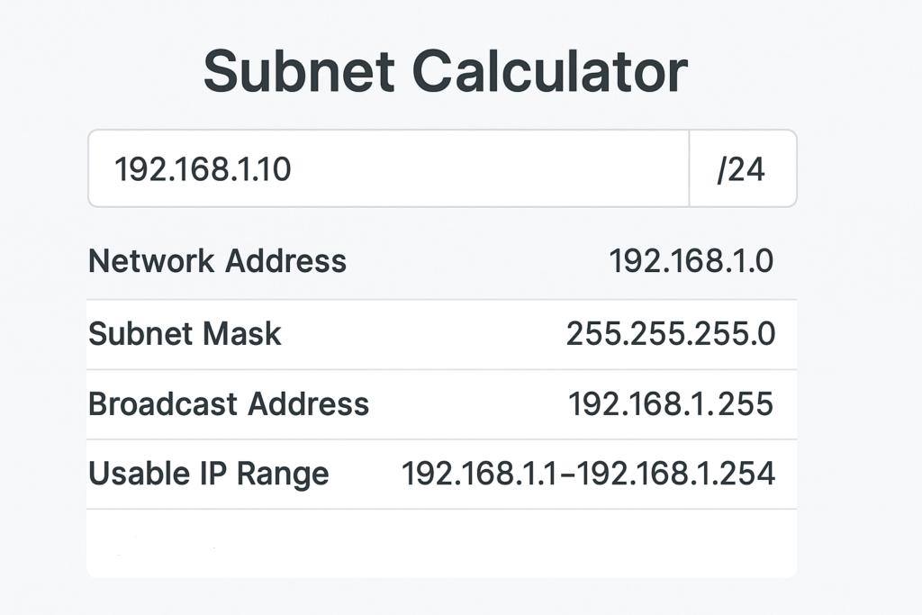
Step 1: Open the website
Visit subnet-calculator.com in your browser.
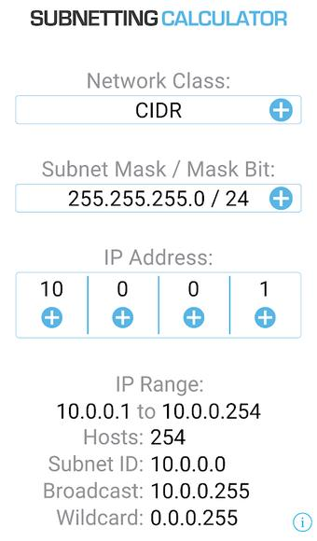
Step 2: Enter the values
Enter IP address 10.0.5.17 and select subnet mask 255.255.255.0 or prefix /24.
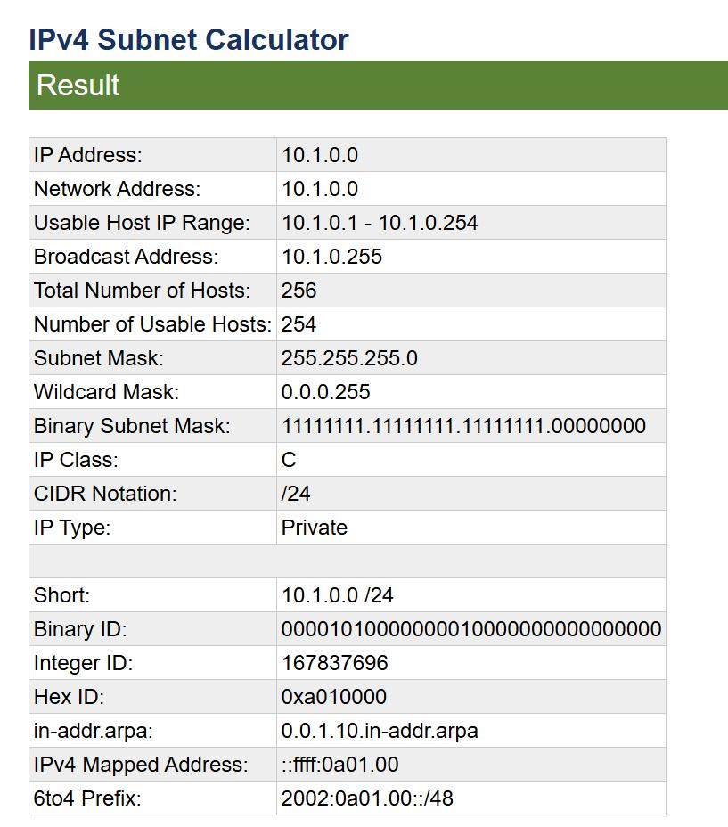
Step 3: Check the results
Confirm that the network ID is 10.0.5.0, the broadcast address is 10.0.5.255, and the usable host range is 10.0.5.1–10.0.5.254.
Step 4: Take a screenshot
On Windows, press Win + Shift + S, select the calculator results, and save or paste the screenshot into your practical assignment.
Expected verification result
Calculator field | Expected value
IP address | 10.0.5.17
Subnet mask | 255.255.255.0
CIDR prefix | /24
Subnet ID / Network address | 10.0.5.0
Broadcast address | 10.0.5.255
Host range | 10.0.5.1 – 10.0.5.254
Usable hosts | 254
One-line observation for your assignment

